S3 – GROUP BY - AVG -SUM

# What you will know:

GROUP BY – AVG - SUM

# Instructions:

* Open [this online SQL editor](https://www.w3schools.com/sql/trysql.asp?filename=trysql_op_in)
* Look at the content of the Product table, using a SQL command or by clicking on the link on the right side:

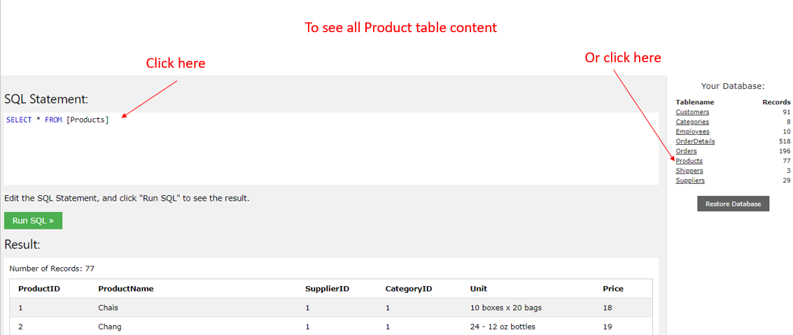

Each product of **Products** table has a **category ID** (*this ID refers to an element in the* ***Categories*** *table*)

## Q1

Write a SQL query to display the **number of products per category**.

Expected columns:

CategoryID Number of items

**Your query:**

**SELECT CategoryID,COUNT(ProductID) as " Number of items" from Products GROUP BY (CategoryID);**

## Q2

Write a SQL query to display the **average price** of items per category ID.

Expected columns:

CategoryID Average items price

**Your query:**

SELECT CategoryID,AVG(Price) AS "Average item price" from Products GROUP BY CategoryID;

## Q3

Write a SQL query to display the **total of the price** of all items per category ID.

Expected columns:

Category ID Total items price

**Your query:**

**SELECT CategoryID AS "Category ID",SUM(Price) AS "Total item price" from Products GROUP BY CategoryID;**